Day 2: EXERCISE – 2

INTERNSHIP TASKS

Name : S. Deva Manikanta

Clg Id : 12119003

Course : Python

Org : IGIAT – VSKP

Date : 20-03-2024

**Level – 1:**

#Task 1 : Inside 30DaysOfPython create a folder called "day_2". Inside the folder create a file named 'variables.py'

#Task 2 : Write a python comment saying 'Day 2: 30 Days of python programming'

#Task 3 : Declare a first name variable and assign a value to it.

first_name = "Deva Manikanta"

#Task 4 : Declare a last name variable and assign a value to it.

last_name = "Sala"

#Task 5: Declare a full name variable and assign a value to it.

full_name = "Deva Manikanta Sala"

#Task 6: Declare a country variable and assign a value to it.

country = "India"

#Task 7: Declare a city variable and assign a value to it.

city = "Palacole"

#Task 8: Declare an age variable and assign a value to it.

age = 20

#Task 9: Declare a year variable and assign a value to it.

year = 2024

#Task 10: Declare a variable is_married and assign a value to it.

is_married = False;

#Task 11: Declare a variable is_true and assign a value to it.

is_true = True;

#Task 12: Declare a variable is_light_on and assign a value to it.

is_light_on = False;

#Task 13: Declare multiple variable on one line.

a, b, c = 10, 20, 30;

**Level – 2:**

#Task 1 : Check the data type of all you variables using "type()" built-in function.

print("Type of first_name : ", type(first_name));

print("Type of last_name : ", type(last_name));

print("Type of full_name : ", type(full_name));

print("Type of country : ", type(country));

print("Type of city : ", type(city));

print("Type of age : ", type(age));

print("Type of year : ", type(year));

print("Type of is_married : ", type(is_married));

print("Type of is_true : ", type(is_true));

print("Type of is_light_on : ", type(is_light_on));

print("Type of a : ", type(a));

print("Type of b : ", type(b));

print("Type of c : ", type(c));

print("\n\n");

#Task 2 : Using the 'len()' built-in function, find the length of your first name

print(f"Length of First Name - \"{first_name}\": {len(first_name)}");

#Task 3 : Compare the length of your first name and your last name

print(f"\nThe Length of First Name - \"{first_name}\" : {len(first_name)} and Last Name - \"{last_name}\" : {len(last_name)}");

print(f"lengths of first_name > last_name: ", (len(first_name) > len(last_name)));

print(f"lengths of last_name > first_name: ", (len(last_name) > len(first_name)));

#Task 4 : Declare 5 as num_one and 4 as num_two

num_one, num_two = 5, 4;

# 4.a) Add num_one and num_two and assign the value to a variable total

total = num_one + num_two;

print("Total : ", total);

# 4.b) Subtract num_two from num_one and assign the value to a variable diff

diff = num_two - num_one;

print("Diff : ", diff);

# 4.c) Multiply num_two and num_one and assign the value to a variable product

product = num_two * num_one;

print("Product : ", product);

# 4.d) Divide num_one by num_two and assign the value to a variable division

division = num_one/num_two;

print("Division : ", division);

# 4.e) Use Modulus division to find num_two divided by num_one and assign the value to a variable remainder

remainder = num_two % num_one;

print("Remainder : ", remainder);

# 4.f) Calculate num_one to the power of num_two and assign the value to a variable exp

exp = num_one ** num_two;

print("Exp : ", exp);

# 4.g) Find the floor division of num_one by num_two and assign the value to a variable floor_division

floor_division = num_one // num_two;

print("Floor Division : ", floor_division);

#Task 5: The Radius of a Circle is 30 meters.

# 5.a) Calculate the area of circle and assign the value to a variable name of area_of_circle.

# 5.b) Calculate the circumference of a circle and assign the value of a variable name of circum_of_circle.

# 5.c) Take radius as user input and calculate the area and circumference

import math;

radius = float(input("\n\nEnter the radius : "));

area_of_circle = math.pi * (radius ** 2); # πr²

circum_of_circle = 2 * math.pi * radius; # 2πr

print(f"Area of Circle with radius({radius}) : ", area_of_circle);

print(f"Circumference of Circle with radius({radius}) : ", circum_of_circle);

#Task 6: Use the built-in input function to get first name, last name, country and age from a user and store the value to their corresponding variable names.

first_name = input("\n\nEnter your first name : ");

last_name = input("Enter your last name : ");

country = input("Enter your country name : ");

**OUTPUT:**

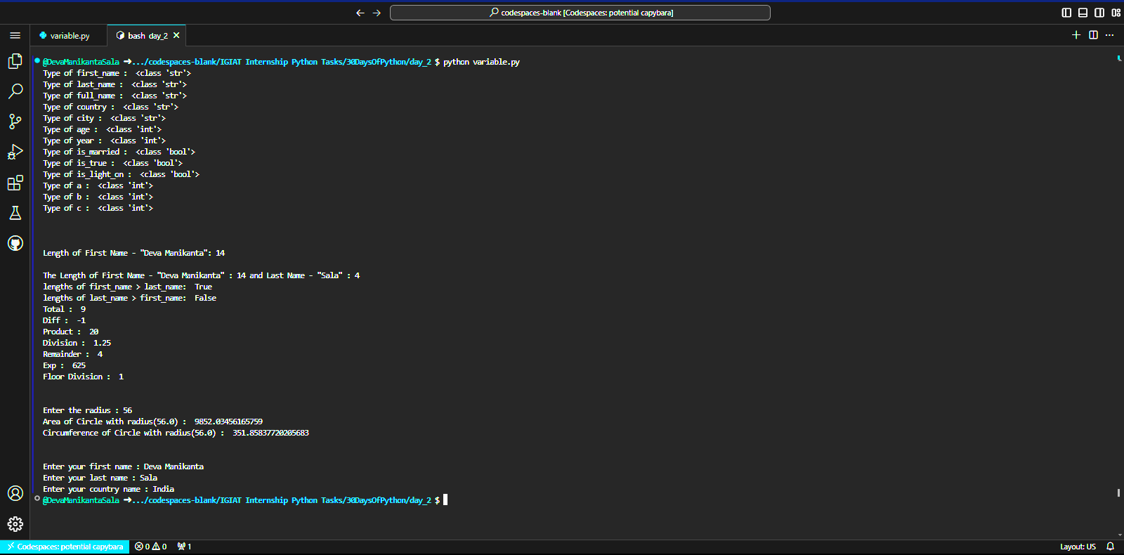

#Task 7: Run help('keywords') in Python shell or in your file to check for the Python reserved words or keywords. – screeshot as follows in shell..

